2016 Spring Board

Names of Participants – Pastor Tassey, Pastor Mueller, Pastor Ratcliffe, JR Townsen, Sandra Hernandez, Jennifer Krupp, Nathan Nehrt, Dand Baker, Ethan Boester, Aaron Fosse, Devin Braummeer, Brittany Jennett, Pastor and Rebecca Nehrt

Agenda Items

Executive Director’s Report (at the end of the minutes)
Business Manager’s Roport (at the end of the minutes)

- 2016 Summer Training Plans
Location – St. John’s Seward
St. Paul’s, Malcolm
Good Shepherd, Milford
Trinity, Lincoln

Workshops
Patty Stradley – Finances for Youth and Church

Registration – As of 4/6 there are 10 registered for summer training

Publicity
Sent postcards
Created and sent fliers, brochures, planning packets

- Local Groups – I’ve taken a number of calls and emails about pastors and congregations interested in OAFC. (Something we’re doing is working!) I’ve passed their information along to the nearest local directors. One, from Florida, is interested in possibly having a Travel Team come down.
- Committee Work –
- Sexual Misconduct – Nehrt’s created a working draft and sent it to the me (we need to unify the language we use to describe leaders in OAFC to move forward on the policy.
- Early Arrivers Activities – not needed. No one has expressed a need to arrive earlier than the registration time and date.

Business Report

- Weekend Reports Received - St. Andrew Lutheran Church, Houston, TX

- We worked with Pastor Tassey in January and February to complete the re-application to keep OAFC’s LCMS Recognized Service Organization status. We know that the synod office has received all necessary documents, they are behind on reviewing them so we have not heard an official word, except that the documents are in the synod’s office.

- In January, OAFC received a memorial in honor of Rev. Fred Darkow from the Office of National Mission to advance our ministry. The amount was $5000.00.

- Update on the sexual misconduct policy-- In January 2015, our insurance company sent OAFC a letter that stated that if OAFC did not have a written sexual misconduct policy, our insurance for Sexual Misconduct might be dropped. In the summer and fall of 2015, the insurance company revised this decision because small organizations like OAFC were having difficulty creating and implementing a policy to meet the requirements of the insurance company. We have been working with Pastor Tassey and our insurance representative, and she replied, “As it stands right now, you don’t need to change anything to keep the Sexual Misconduct limits that you currently carry. Your current limits are $50,000 each claim and $100,000 aggregate. All of the stricter procedures – like background checks and the 2 adult rule must be implemented for limits of $500,000 or above. If you are interested in higher limits, let me know and I will send your procedures to underwriting for review.” As a result of her comment, we have decided to keep what we have worked on, but not bring it up for a vote at this time.

- Required Background Checks – When I began my work as business manager, I was given the instruction that I needed to use Protect My Ministry to run background checks for OAFC. I was also given a list of dates on which I needed to rescreen certain individuals. I asked for the guidelines of who should have a background check done, and was not given an answer. I was hoping that writing the sexual misconduct policy would give the answer. But since we are not implementing a policy at this time, I am asking that as a board, you either write a background check policy or decide not to do background checks anymore. Pastor Tassey recently told me that on the Lead Director application, it states that a background check will be conducted. The list of names that have had background checks and now need to be rescreened does not match up with the list of Lead directors on the website. I would appreciate a clear policy that says something like, “When a lead director and assistant director is appointed over a local OAFC group they will be required to have a background check. These individuals will be rescreened every two years.” What about travel team leaders? What about Pastors as Lead Directors? What about Board Members?

- Work is being done to get summer training tubs restocked and updated.

Financial Report 1/1/2016 through 4/14/2016
Balance Checking - $53,563.20
Balance LCEF - $36,334.57

INCOME

Donations
AmazonSmile 6.35
Church Donation 689.99
Individual Donation 2,433.00
LCMS Foundation 8,426.24
Memorial Donation 5,140.00
Thrivent Choice 1,092.00
Vanco:Individual Donation 225.00

Paypal
Paypal:Individual Donation 4,077.60
Paypal:Purchase And Shipping 204.10
TOTAL Paypal 4,281.70

Weekend Door Offering
Weekend Door Offering:Texas 276.50

Zion Lutheran Church 1,161.00 (This amount belongs to the Texas group)

TOTAL INCOME 23,946.88

EXPENSES

2016 Director's Salary 3,360.00

Bank Service Charge:Vanco 1.80

Business Expenses
Business Expense:Corporation Fee 10.00
Business Expense:Ins. Bus. Auto 213.00
Business Expense:Mailing Supplies 49.00
Business Expense:Post Office Box 60.00
Business Expense:Tax Preparer 32.50
Business Expense:Website 469.00
Business Expense:Shipping 34.96
TOTAL Business Expense 868.46

TOTAL EXPENSES 4,230.26

OVERALL TOTAL 19,716.62
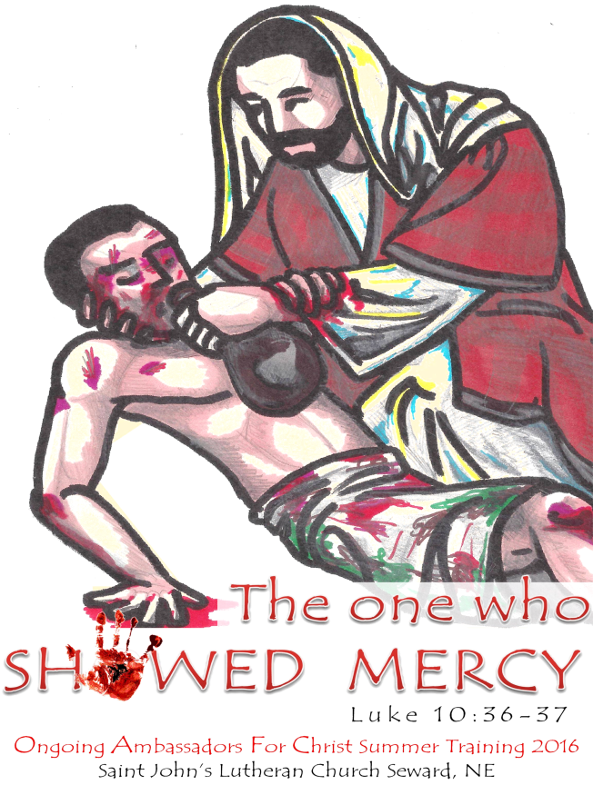
OAFC Spring Board Meeting Agenda
Opening Prayer: Pastor Tassey

Pastor Matthew Tassey
Pastor & Rebecca Nehrt
Pastor Andrew Ratcliffe
Pastor Jacob Mueller
JR Townsend
Sandra Hernandez
Jennifer Krupp
Nathan Nehrt
Dana Baker
Ethan Boester
Aaron Fosse
Devin Brammeier
Brittany Jennett

Reports:

Executive Director's Report –
Ministry Picture: With an early Lent this year, I have not been able to do as much as I would have liked for OAFC. On top of the extra services at St. Paul’s in Malcolm, I’ve had 2 funerals with deathbed ministry for the week prior during Lent, Evie had to have tubes and her adenoids removed, we just finished our NE District Pastors’ Conference, and our church is struggling with establishing and implementing a solid delinquent follow-up ministry. So I just haven’t had time. Now that Easter is past, I hope to be able to do more.

National Youth Gathering
• I have met with and planned out the Evangelism Academy
• 3 Session Academy—1 Session Training, 1 Session Street Evangelism, 1 Session Recap
• In conjunction with the Synod’s Witness and Outreach Leaders (Rev. Mark Wood and his team)
• I have registered for an exhibit booth
• I am trying to coordinate with the NYG folks, Lohman and Kiesling, to define how we’re supposed to register the Team—because it’s $325 for each addition person at the booth

Summer Training 2016 Planning
• Churches—To whom I have sent full information packets
• St. John’s, Seward
• St. Paul’s, Malcolm
• (Good Shepherd, Milford)
• (Trinity, Lincoln)
• (~ Christ, Columbus)
• (~ Immanuel, Lincoln)
• Workshops
• Patty Stradley—Finances for Youth and the Church
• Registration
• As of 4/6 we have 10 registered for ST
• 3 Adults, 2 College, 5 youth
• 3 Board Members
• Publicity
• Sent Postcards
• Created and Sent Fliers, Brochures, Planning Packets

ACTION NOTE: I’d really like to look into moving registration for Summer Training from the Spring to the Fall prior to Summer Training for the sake of planning.
• For example, as of right now, how many host churches, nursing homes, team leaders, etc do I actually need to line up?
In the past, it was generally assumed that we would reach the same number of registrations each year, some years even having to cap registrations. In recent years, we have struggled to reach 80. Especially during NYG years, registration drops. But this year, is that going to be a drop of 10, 20; will we have 50 or 75 or maybe even 100 people at Training? Planning with this uncertainty is not helpful or efficient. In my nearly 20 years in OAFC, we’ve done registration in the Spring. So this would be a big change. But I think we need it.

Local Groups:
• I’ve taken a number of calls and emails about pastors and congregations interested in OAFC. (Something we’re doing is working!) I’ve passed their information along to the nearest local directors. One, from Florida, is interested in possibly having a Travel Team come down.

Committee Work
• Sexual Misconduct—created a working draft and sent it to the committee members (we need to unify the language we use to describe leaders in OAFC to move forward on the policy.
• Early Arrivers Activities—in talking with the Seward folks, they also are planning to drive and so will arrive later. I’ve also not yet received any word that there are folks coming early. ????

Business Manager's Report –
- Weekend Reports Received - St. Andrew Lutheran Church, Houston, TX
- We worked with Pastor Tassey in January and February to complete the re-application to keep OAFC’s LCMS Recognized Service Organization status. We know that the synod office has received all necessary documents, they are behind on reviewing them so we have not heard an official word, except that the documents are in the synod’s office.
- In January, OAFC received a memorial in honor of Rev. Fred Darkow from the Office of National Mission to advance our ministry. The amount was $5000.00.
- Update on the sexual misconduct policy-- In January 2015, our insurance company sent OAFC a letter that stated that if OAFC did not have a written sexual misconduct policy, our insurance for Sexual Misconduct might be dropped. In the summer and fall of 2015, the insurance company revised this decision because small organizations like OAFC were having difficulty creating and implementing a policy to meet the requirements of the insurance company. We have been working with Pastor Tassey and our insurance representative, and she replied, “As it stands right now, you don’t need to change anything to keep the Sexual Misconduct limits that you currently carry. Your current limits are $50,000 each claim and $100,000 aggregate. All of the stricter procedures – like background checks and the 2 adult rule must be implemented for limits of $500,000 or above. If you are interested in higher limits, let me know and I will send your procedures to underwriting for review.” As a result of her comment, we have decided to keep what we have worked on, but not bring it up for a vote at this time.
- Required Background Checks – When I began my work as business manager, I was given the instruction that I needed to use Protect My Ministry to run background checks for OAFC. I was also given a list of dates on which I needed to rescreen certain individuals. I asked for the guidelines of who should have a background check done, and was not given an answer. I was hoping that writing the sexual misconduct policy would give the answer. But since we are not implementing a policy at this time, I am asking that as a board, you either write a background check policy or decide not to do background checks anymore. Pastor Tassey recently told me that on the Lead Director application, it states that a background check will be conducted. The list of names that have had background checks and now need to be rescreened does not match up with the list of Lead directors on the website. I would appreciate a clear policy that says something like, “When a lead director and assistant director is appointed over a local OAFC group they will be required to have a background check. These individuals will be rescreened every two years.” What about travel team leaders? What about Pastors as Lead Directors? What about Board Members?
- Work is being done to get summer training tubs restocked and updated.

Financial Report 1/1/2016 through 4/14/2016
Balance Checking - $53,563.20
Balance LCEF - $36,334.57

INCOME
Donations
AmazonSmile 6.35
Church Donation 689.99
Individual Donation 2,433.00
LCMS Foundation 8,426.24
Memorial Donation 5,140.00
Thrivent Choice 1,092.00
Vanco:Individual Donation 225.00

Paypal
Paypal:Individual Donation 4,077.60
Paypal:Purchase And Shipping 204.10
TOTAL Paypal 4,281.70

Weekend Door Offering
Weekend Door Offering:Texas 276.50

Zion Lutheran Church 1,161.00 (This amount belongs to the Texas group)

TOTAL INCOME 23,946.88

EXPENSES

2016 Director's Salary 3,360.00

Bank Service Charge:Vanco 1.80

Business Expenses
Business Expense:Corporation Fee 10.00
Business Expense:Ins. Bus. Auto 213.00
Business Expense:Mailing Supplies 49.00
Business Expense:Post Office Box 60.00
Business Expense:Tax Preparer 32.50
Business Expense:Website 469.00
Business Expense:Shipping 34.96
TOTAL Business Expense 868.46

TOTAL EXPENSES 4,230.26
OVERALL TOTAL 19,716.62

Committee Reports –
Early Arrivers Details Planning Committee
- Pr. Tassey, Rebecca Nehrt, Aaron Fosse
- Pr. Tassey & Pr. Ratcliffe to make suggestions list
Nominations Committee
- Jennifer Krupp, Devin Brammeier, Aaron Fosse
- We need a few more recommendations for the Committee
- Updated Nominations List to the Board by June 1 for approval
Workshops Committee
- JR Townsend, Dana Baker
- Let the little children come to Me. - this workshop would help groups during their local weekends offering some "how-to's" when it comes to choosing a theme, songs, puppet plays, etcetera for Sunday school. Beth Fosse
- Jehovahs, and Mormons, and Muslims, oh my! - this workshop I was thinking would run two or more sessions, giving an in-depth analysis of common religions we run into during canvassing and how to respond to "tougher" situations, such as witnessing without the Bible. Rev. Jeffrey Nehrt or (Rev. Brent Kuhlman @ Trinity Murdock)
- Rub-a-dub-dub thanks for the grub, amen! - designed to help people who aren't as outgoing to learn how to pray aloud. (Rev. Loy Schlotte?)
- You are the light of the world. - designed for H.S. or college students who are constantly tempted by the world's desires, it would aim to give these students strategies on resisting temptations and providing a better outlet of expression. Rev. Andrew Ratcliffe
- Biblical History - led by one of the Pastor's, aiming to shed some light on the historical setting of perhaps a certain passage and how that influenced the writer and/or what was written. An active approach at understanding scripture. (Rev. Mark Mehl?)
- Fervent Feet – a workshop geared towards applying OAFC methods in your mission field, your area of influence. An aid to break down common barriers with family and friends. (Rev. Peter Kirby?)
- How do you know? – this workshop is designed to instruct people how to respond to claims of the validity of the Bible or retorting claims that God does not exist. (Dave Pratt? Rev. Matthew Tassey or someone from CUNE)
- Digital Outreach – Music and Outreach in a digital age, JR Townsend
- Jesus & The Passover (If Mark Mehl can't teach the Biblical History) – Jennifer Krupp
- Thrivent Money and Stewardship – Patty Stradley

Bible Studies Committee
- Pr. Jacob Mueller, Ethan Boester
- Texts selected: Psalm 130, Luke 10:25-37, 1 Timothy 1:12-20 (MERCY)
Sexual Misconduct Policy Committee [Rename: Background Check Policy Committee]
- Pr. Jeffrey Nehrt, Rebecca Nehrt, Pr. Tassey
- Jennifer Krupp will work to draft wording for a policy to determine procedures for Background Checks that we will do with Protect My Ministry

Business:

Old Business –

New Business –
Motion to transfer $20,000 from the BNB to the LCEF Account
- Leaves $33,563.20
Texas Group LWML District Exhibit Reimbursement –
- $687.31 Moved to cover the full cost for the Texas folk

Adjournment –

Closing Prayer:

